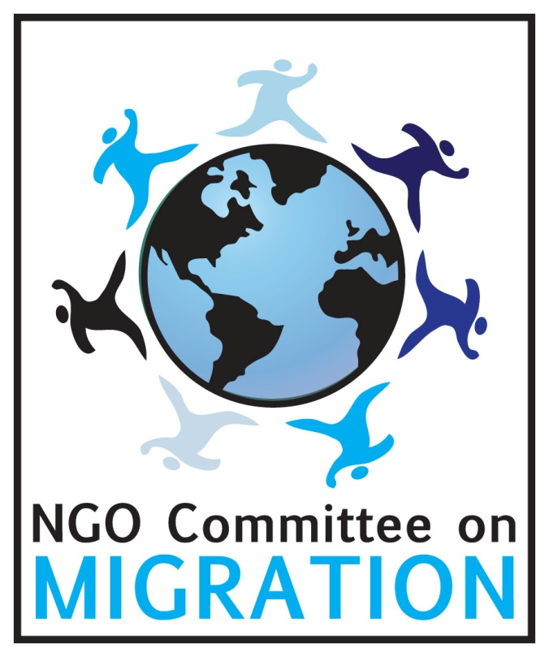
ting
Giving Childhood Back to
Children in Refugee Camps

Civil Society Recommendations

The Convention on the Rights of the Child (CRC) establishes the basic rights of all children, including those living in refugee camps.Yet, hundreds of thousands of children in refugee camps around the world are suffering from the violation of their rights. The developmental and psychological consequences, particularly for children under the age of five, can be devastating.
Sovereign host States hold the primary responsibility for ensuring respect for the human rights and safety of all forcibly displaced persons in refugee camps. It is therefore imperative to reduce the implementation gap between the rights enshrined in the CRC and the actual living conditions of children, especially the most marginalized, in refugee camps.
These children must be considered as active survivors not as passive and invisible victims. The correct implementation of the CRC and of the best interest of the child by host States provides a stable normative bridge between humanitarian situations and development contexts. The benefits are multiple: the prevention and amelioration of toxic stressors, laying the groundwork for resilience, recovery and renewed development. In particular, the promotion of the right to quality education at all levels, starting from Early Childhood Development, plays a fundamental role in teaching self-reliance, creating the human and social capital needed for development, breaking the cycle of poverty and contributing to peace-building.
The key component of a policy on alternatives to refugee camps, moving from humanitarian assistance towards greater autonomy, is undoubtedly represented by the protection of refugee children’s rights from their very birth, paving the way for their eventual successful social integration into newly urbanized populations either in the country of origin or the new host country.
To accomplish this goal, the undersigned civil society organizations worldwide, offer the following recommendations.
It is the responsibility of States, with the support of the international community as a whole, to:

1 Collect and share disaggregated data by age, gender, country of origin, education, and other relevant information about refugee children in camps and those in urban areas.
Timely, comparable, and accessible data are important to formulate effective measures to ensure the protection of children’s rights when they are confronted with a range of risks, violence and abuse. Policy discussions go amiss without such data.

2 Make clear in domestic legislation, policy and practice, that the principles of:

- non-discrimination (CRC, art.2);
- the best interest of the child (CRC, art.3, par.1);
- the right of survival and development (CRC, art.6);
- the right of the child to express his or her view and to have taken it into account (CRC, art.12)

must be implemented in the refugee camps.

These are the fundamental values of the Convention, and States have legal obligations to comply with them.

3 Ensure that the best interest of the child is a primary consideration in all actions of States or private institutions concerning every child, regardless of his or her migration status, including unaccompanied and separated children as well as children in refugee camps. The CRC clearly states additional situations that are not in the best interest of the child, such as: to be exposed to any form of violence (art.19); to be wrongly separated from his or her parents (art.9); to be exploited or abused (arts. 33-36).
Furthermore, the best interest of the child must be determined on a case-by-case basis, according to the specific situation of the child and of children as a group.
The standard for case management is the formal Best Interest Procedure (covering Best Interest Assessment (BIA) and Best Interest Determination (BID) established by UNHCR for the protection of vulnerable asylum-seeking and refugee children, including Unaccompanied and Separated Children (UASC).

4 Recognize the particular vulnerabilities of refugee children, during the preflight, flight and resettlement phases, and conduct a child protection assessment by trained staff, in full compliance with the CRC.
Refugee children encounter traumatic scenarios in the country of origin (violence, loss of family members, friends, homes), in the countries of transit (dangerous transit, day-to-day uncertainty, deprivation of basic needs, parental separation), and in refugee camps in the host country. It is critical to make refugee children’s particular vulnerability to violence a priority issue for action by all relevant stakeholders within the UN system.
5 End the restrictions in refugee camps on children’s rights guaranteed by the CRC. States must treat children in refugee camps as active rights holders, and inform them of their rights.

In refugee camps children face high risks of exploitation, human trafficking, underage marriage, violence and abuse, recruitment into armed groups, and organized crime. They experience a high level of toxic stress, with mental and physical health consequences that last into adulthood. It is critical to develop and support campaigns to raise awareness of the rights of refugee children so as to prevent discrimination and marginalization and to ensure respect for their identity.
6 Ensure the right to quality education for refugee children (CRC, art. 28-29). Education is a fundamental right that does not expire in emergency situation.

Attending school helps to mitigate the devastating psychological impact of living in a refugee camp. With age-appropriate, culturally sensitive attention, resilience can be fostered and coping and healing can begin. Moreover, it is necessary to focus on higher education and long-term capacity building among refugee children, especially adolescents. Higher education is important for both individuals and society to rebuild lives and foster leadership in both protracted settings and peaceful post-conflict reconstruction. Without higher education there will be no qualified teachers for primary education; thus, it is fundamental to adopt a well-balanced and holistic approach to supporting education at all levels.

7 Protect the youngest children (birth to five) at high risk of trauma-related disruptions, promoting Early Childhood Development (ECD).
The adverse relationships between toxic stress and children’s development have long been established by psychological research. Early Childhood Development programs provide psychological, physical, emotional and cognitive protection. They have the potential to contribute in significant ways to peace-building by promoting non-violent attitudes and behaviors in children, especially high-risk children in conflict-ridden refugee camps.

8 Host States need the support of Civil Society and the international community to find durable solutions to end the many protracted refugee situations, which already span 2nd and 3rd generations.

The preamble of the CRC states that the child “should be fully prepared to live an individual life in society”, not in a refugee camp.

9 States must support and promote an alternative to camps which enables refugees, including children, to lead more dignified, productive lives and to contribute to their host societies.
The escalating trend in forced displacement and humanitarian needs is likely to continue, while humanitarian financing is close to bankruptcy. Incorporating refugees in the post-2015 development agenda would promote active participation of refugee youth in their own development as well as that of their host countries.

1 CRC Status of the Convention on the Rights of the Child. Report of the Secretary General, A/69/260, 19 August 2014.
2 UN Security Council Resolution 1208 (1998) on the maintenance of the security and civilian and humanitarian character of refugee camps and settlements in Africa, 19 November 1998. The primary responsibility of host countries is “to ensure the security and civilian and humanitarian character of refugee camps and settlements in accordance with international refugees, human rights and humanitarian law.”
3 Half of the world’s forcibly displaced people (51.2 million) are children, UNHCR Global Trends Report, 2013. Displacement data covers three different groups: refugees (6.7 million), asylum seekers (1.1 million) and internally displaced (33.3 million)
4 The most populated refugee camps are : Dadaab ,Kenya (approx. 500.000), Dollo Ado, Ethiopia (198.000), Kakuma, Kenya (124.000), Al Za'atari, Jordan (122.000), Jabalia, Gaza Strip (110.000), Mbera, Mauritan (75.000), Yida, South Sudan (70.000), Nakivale, Uganda (68.000), Nyarungusu, Tanzania, 68.000; Tamil Nadu, India, (66.000).
5 CRC General Comment No. 5 (2003) on the general measures of implementation of the Convention on the Rights of the Child, para. 12; and No. 12 (2009) on the right of the child to be heard, para. 2.
6 CRC Status of the Convention on the Rights of the Child. Report of the Secretary General, A/69/260, 19 August 2014.
7 Committee on the Rights of the Child, General comment No. 14 (2013) on the right of the child to have his or her best interests taken as a primary consideration (art. 3, para. 1).
8 Art. 22 of the CRC gives the right to receive appropriate protection and humanitarian assistance to a child seeking asylum status or who is considered a refugee. It seems timely that art. 22 emphasize and express by explicit wording the need for appropriate protection for every child, regardless of his or her migration status. In the case of the refugee and asylum seekers the best interest should be determined also with regard to other human rights norms such as those covered in the Convention relating to the Status of Refugee (1951) and its protocol (1967), the Convention governing the specific aspects of refugee problems in Africa of the Organization of African Unity (OUA) (1969), the Cartagena Declaration of Refugees (1984) and San Jose Declaration (1994).
9 CRC General Comment No.6 (2005) on the Treatment of unaccompanied and separated children outside their country of origin.
10 See the Optional Protocol on the sale of children, child prostitution and child pornography; (2002); the Optional protocol on the involvement of children in armed conflicts (2002); the Optional Protocol on a communication procedure (2014). This Protocol allows children from States that have ratified it to bring complaint about violations of their rights directly to the UN Committee on the Rights of the Child if they have not found solution at national level.
11 ECD incorporates all aspects of human development, including the physical, language, cognitive, intellectual, social, emotional, moral and ethical domains. ECD and Early Childhood Education and Care (ECEC) incorporate health, mental health, sanitation and hygiene and nutrition as well as learning and school performance.
¹² Shonkoff J., Richter, L., van der Gaag J. & Bhutta, Z.A. (2012), An integrated scientific framework for child survival and early childhood development, Pediatrics, 129(2), 1-13.
13 OMEP, The World Organization for Early Childhood Education, with members in more than 70 countries strongly support efforts to ensure the well-being of children in refugee and crisis situations. OMEP is developing material for use by volunteers working with children in these situations.
14 Statement by Antonio Guterres, United Nations High Commissioner for Refugees. Third Committee of the General Assembly, 69th Session, 5 November 2014. See also UNHCR, Policy on Alternatives to Camps, 2014; Refugee Economies. Rethinking Popular Assumptions, Humanitarian Innovation Project (HIP), University of Oxford, 2014. 5 January 2015

